JECRC
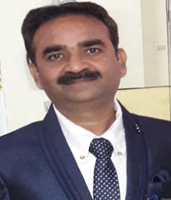

JAIPUR

INDIVIDUAL FACULTY DATA SHEET
Name of the faculty member | : | Shailendra Shrivastava
Present Designation | : | Assistant Professor
Email Id:Shailendra.ee@jecrc.ac.in
Contact Details:9024699748

I. Particulars of Educational Qualification: (only completed)

Category | Name of the Degree | Specialization | Year of Passing | Name of the College | Name of the University
UG | B.E. | Electrical Engineering | 2007 | MITS, Gwalior (M.P.) | RGPV, Bhopal (M.P.)
PG | M.Tech. | Power System | 2009 | SBCET, Jaipur (Raj.) | RTU, Kota (Raj.)
Ph.D.

II. Academic Experience : 10 Year

III. Industrial Experience :

IV. Title of Ph.D. Thesis :

V. Awards/Achievements :

VI. Research/Specialization :

VII. Course Taught : B.Tech., M.Tech

VIII. Refereed International Journal Publication : Two

IX. International Conference Proceeding :Two

X. Books Written :

XI. M.Tech Thesis Guide : One

XII. PHD Thesis Guide :

XIII. Professional Body Membership :

